**ASSIGNMENT 33.3**

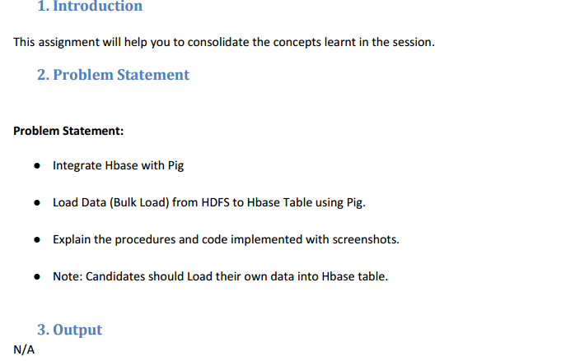

We are taking sample data set of EMP_DETAILS which will be loaded into HBase.

We will be copying the data set in to HDFS which will be further loaded into HBase.

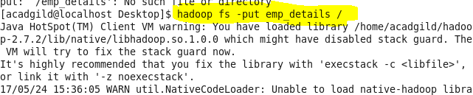

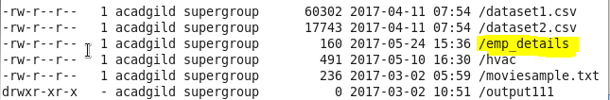

Sample dataset:

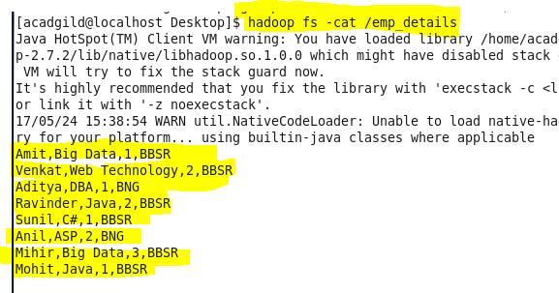

We will be including few jar files of HBase to the Pig classpath.



We will now start HBase shell and create a table.

We only need this table as skeleton so PIG can Store data inside this by referring the table name.

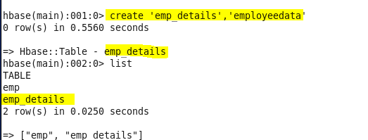

We can come out from HBase by typing exit and switch to PIG grunt shell.

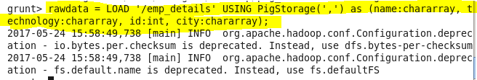

Now we can transfer the data inside HBase by STORE command.



Thus the data is stored in hbase from HDFS via Pig